

|  |  |
| --- | --- |
| Dear Parent,  Your child has chosen to be involved in the Invention Convention. This project is designed to promote your child's problem-solving and creative-thinking skills. Your child will be following a step-by-step process to invent a new product or develop a new method for doing something.  The first step in the actual invention process will be finding an idea for an invention. Your child has been encouraged to find a problem that needs to be solved and list three ideas. Once turned in, I will meet with your child to determine which invention looks best.  Once your child has settled on an idea and researched it to make sure that the idea has not been used before, an Invention Convention packet will be sent home and your child can then begin the planning stage.  As your child begins the actual process of inventing, your continued interest and encouragement will be helpful. Discuss the progress he or she is making and any problems that are encountered. Remind your child that although inventors often experience failure along the way, they remain persistent and keep trying and thinking of new ideas to solve a problem. Once the invention has been completed, your child may apply for a patent by completing a Patent Application form available through your child’s teacher.  The Invention Convention will be held on Tuesday, May 8th. Specific times will be sent out closer to the event.  You are invited to attend the event. Each student's entry will be judged as will the student's knowledge of his or her invention. A Patent Certificate will be awarded to each participant.  We know your child will enjoy and benefit from this experience in scientific problem solving. Although we want you to encourage your child in this inventive effort, we ask you not to become overly involved in your child's project. Your support and cooperation are greatly appreciated. We hope to see you at the Invention Convention.  **The top 5 projects from the 5th grade will be selected to give their presentation and pitch before a panel of judges while being filmed on Friday, Math 11th. |  |



**Research and Development**

***On a separate piece of paper, type or write out answers to the questions below. Be sure to give detailed answers and pay attention to how many points each part is worth.***

* Describe the problem or improvement that inspired your invention (10 points)
* What topics did you research to make sure your invention is authentic? (5 points)
* Who is your target audience?(5 points)
* Give a detailed description of your invention.(10 points)
* Describe and list the materials of your prototype.(5 points)
* What problems did you encounter?(5 points)
* Give a detailed “pitch”. Include what the problem is and how your product is the solution. This should convince me that I cannot live without your product.(10points)



**Finished Product Requirements/Suggestions**

***Be sure to make plans for displaying your invention at the Invention Convention on Tuesday, May 8th.***

Required:

-an attractive display (Science Board)

-create a promotion plan through posters or other eye-catching materials

-display a prototype of your invention

Suggestions:

-design packaging for your invention

-create an advertisement for your invention

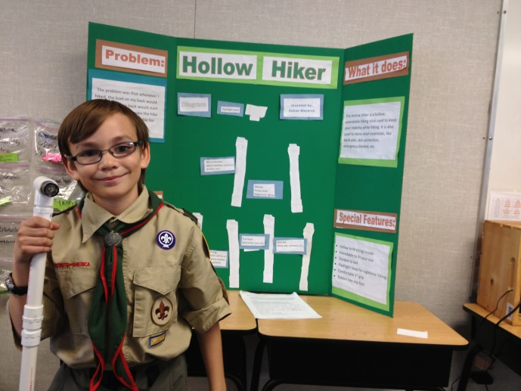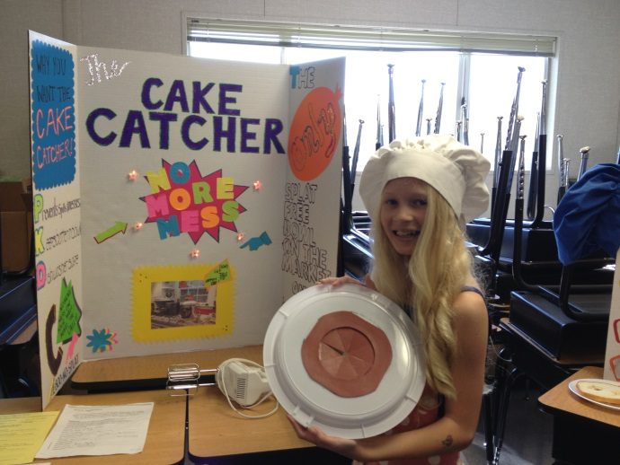



**Timeline**

3 Invention Ideas March 21st

Research and Development May 4th

Invention Convention May 8th

**Invention Convention Rubric**

Pitch ____/15

Knowledge of Product ____/10

Prototype ____/10

Display ____/15

Total ____/50

Comments:

-------------------------------------------------------------------------------------------------

I have read the Invention Convention packet and have reviewed the due dates with my child. I understand that each fifth grade student will be completing an individual project at home.

Parent Signature ______________________

Student Name ________________________